Q8. Check iwconfig/ifconfig to understand in detail about network interfaces (check about interface speed, MTU and other parameters)

**1. Using ifconfig**

ifconfig provides detailed information about all active network interfaces, including their IP addresses, speed, MTU, etc.

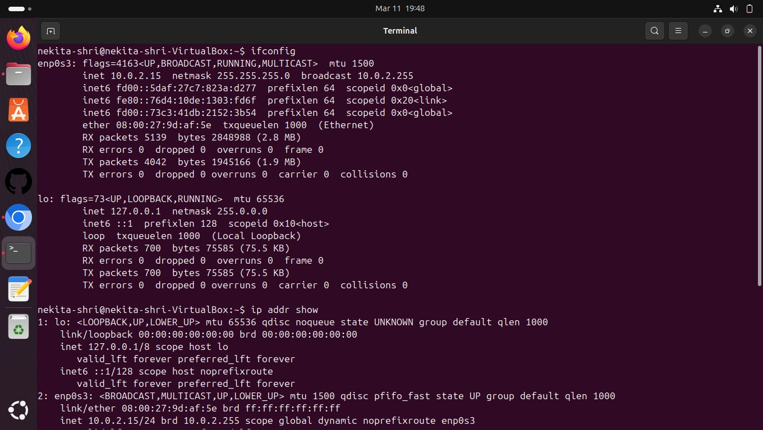

* **MTU:** Maximum Transmission Unit — The largest packet size (in bytes) that can be transmitted in one go. The default for Ethernet is often 1500 bytes.
* **Speed:** Not directly shown in ifconfig, but inferred by the MTU and the interface's capability.
* **RX/ TX packets:** The number of packets received (RX) and transmitted (TX).
* **errors:** Errors that occurred while receiving (RX) or transmitting (TX) packets.
* **collisions:** Occurs when two devices attempt to send data on the network at the same time.
* **HWaddr:** Hardware address (MAC address) of the interface.

### ****Using**** iwconfig ****(Wireless Networks)****

When working with wireless interfaces, iwconfig is the tool that provides more details about the wireless network interface (like signal strength, frequency, etc.).

